ORANGE HRM TOOL ACCEPTANCE CRITERIA AND USER STORY

URL: <https://opensource-demo.orangehrmlive.com/>

US1: As a registered user, I want to login to the application using valid Username and Password

Acceptance Criteria : Given that I’m a registered user, when I fill in the username and password and I click the [Login] button, then I'm successfully able to login with my chosen credentials.

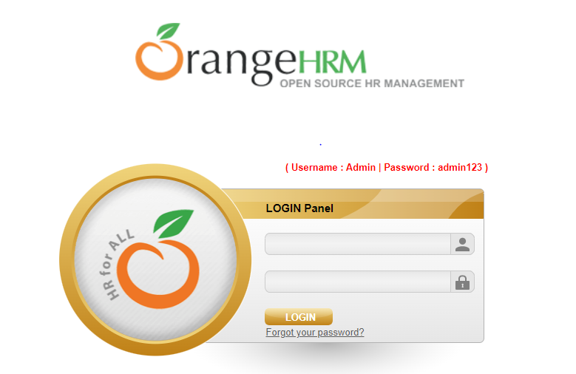

US2: As a logged in user, I want to be able to view the Job titles page present under the Job option of Admin tab.

Acceptance Criteria: Given that I’m a logged in user, when I move to Admin tab on the top bar, then the application shows me User management, Job, Organization, Qualification, Nationalities, Corporate Branding and Configuration as various options.

And I move to Job, then the application shows me “Job Titles” as the top option in the dropdown.

When I click on the “Job Titles” option, I see various Job Titles and their respective Job Description on the same page.

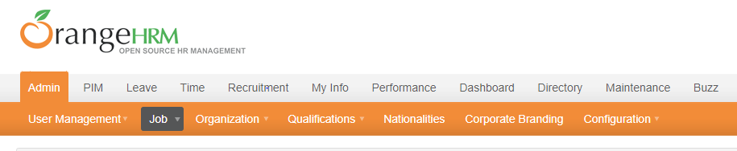

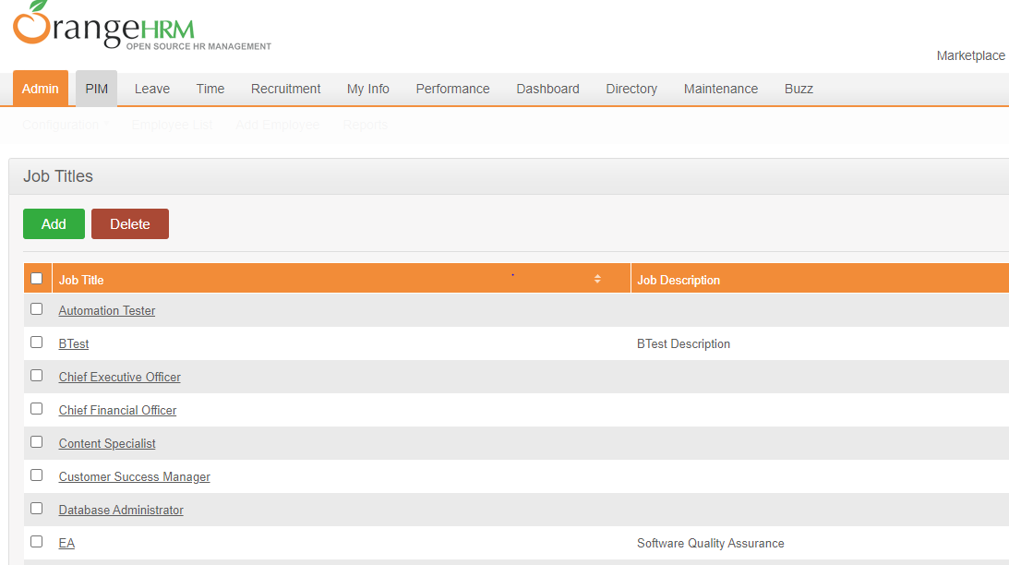

US3: As a logged in user, I want to be able to add my Nationality in the list of Nationalities

Acceptance Criteria: Given that I’m a logged in User, when I move to Admin tab on top bar, then the application shows me User management, Job, Organization, Qualification, Nationalities, Corporate Branding and Configuration as various options.

When I click on “Nationalities”, the application shows me [Add] and [Delete] buttons along with the list of existing Nationalities.

Then I click on [Add] button, the system shows me “Name” which is the required field.

I fill in the “Name” field with “India” and click on [Save] button

Then the system saves my Nationality and shows “Successfully Saved” flash message

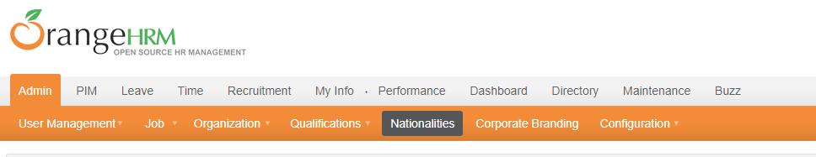

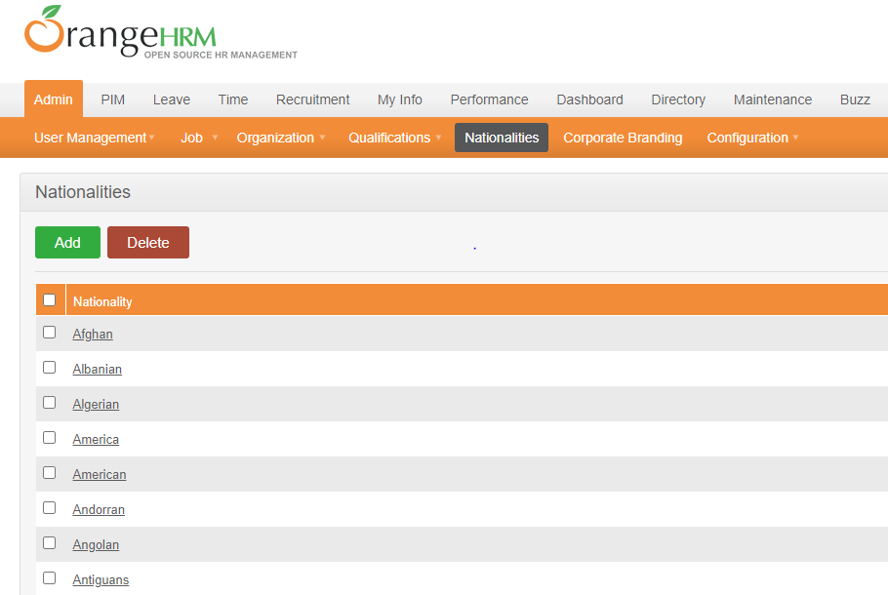

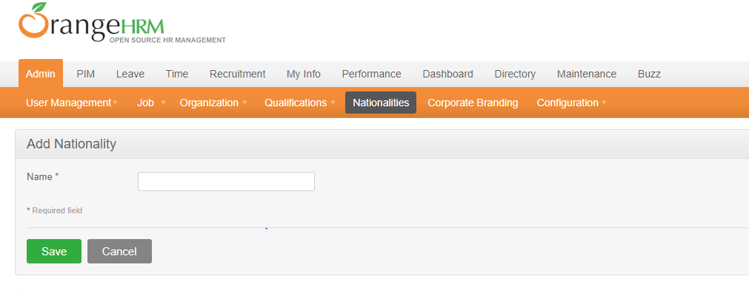

US4: As a logged in User, I want to be able to search an Employee by his name.

Acceptance Criteria: Given that I’m a logged in User, when I move to the PIM tab on the top bar, then the application shows me Configuration, Employee List, Add Employee and Reports as various options.

When I click on “Employee List”, then the system shows me a window containing the Employee Name, Id, Employment Status, Include, Supervisor Name, Job Title and Sub Unit fields.

Then I fill in the Employee Name field with any name I want to search for and click on the [Search] button.

The System shows me details of the Employee.

